**Policy Framework (Case 3)**

*Use this template to develop your Policy Framework. The goal of developing a Policy Framework is to summarize the work done with the EIA and chatbot building to help develop clear policies and governance for implementing the chatbot. Assign someone in your team to be developing this as you go as there will be no time at the end to do this separately.*

**Purpose and Mission**

*Summarize the problem statement, who it serves - the users that the chatbot is targeting.*

Generative AI tools like ChatGPT continues to influence how people live and learn, as well as how they navigate and produce information. It is increasingly likely that students must become literate in using artificial intelligence responsibly before they graduate and start their careers. For this reason, it is critical that instructors must take the time to learn best practices that lead to effective outcomes for their students. When the capabilities of AI are paired with motivated instructors and students, the potential for AI to enhance the teaching and learning experience is undeniably significant.

Teachers are encouraged to integrate AI in their classrooms but the instructions for when, how, and why to use AI are unclear. Our chatbot supports educators in navigating the best use cases for this new technology and provides them with practical guidelines for implementing AI in the classroom.

The target audience is **Educators, such as teachers, teaching assistants, principals, and educational administrators**

* The AI tool needs to assist educators in when, why and how AI should be used.
  + A Thought partner for when educators should use AI.
* This tool does not help teachers grade. It does not help create lesson plans, or teaching content. This tool is solely to help educate those who may use AI in their teaching on when and how to use it effectively.

**Questions of concern that teachers have about use of AI include:**

* Can AI grade fairly?
  + Our thoughts: Depends on the context of the problem and the answerability of the problem.
  + Our thoughts: LLMs are biased on the western historical context so it’s impossible for it to holistically grade homework.
  + Possible solution: Instead of using the AI to grade, teachers can use it to assist in grading a lesson plan or grading framework.
  + Consideration: Can the AI tools be enhanced with teacher’ assessment?
  + Consideration: AI can help with consistency (they don’t get tired)
  + Possible solution: Provide clear and complete instructions
* How do we prevent AI from reinforcing bias?
  + Our thoughts: ChatGPT is biased towards 4Chan Ideology because it is in the training set; we don’t want all content inside the responses of LLMs.
  + Our thoughts: ChatGPT is already biased towards the American liberal ideology.
  + Our thoughts: LLMs are trained heavily with English-language materials created within a Western ideology.
  + Our thoughts: Over time the biases associated with ChatGPT will create a positive feedback loop of information into the training data.
  + Possible solution: Diversify background and prompt context to get different angles
  + Possible solution: Provide additional contexts to GPT i.e. including sources they trust

Chat’s own answer: <https://help.openai.com/en/articles/8313359-is-chatgpt-biased>

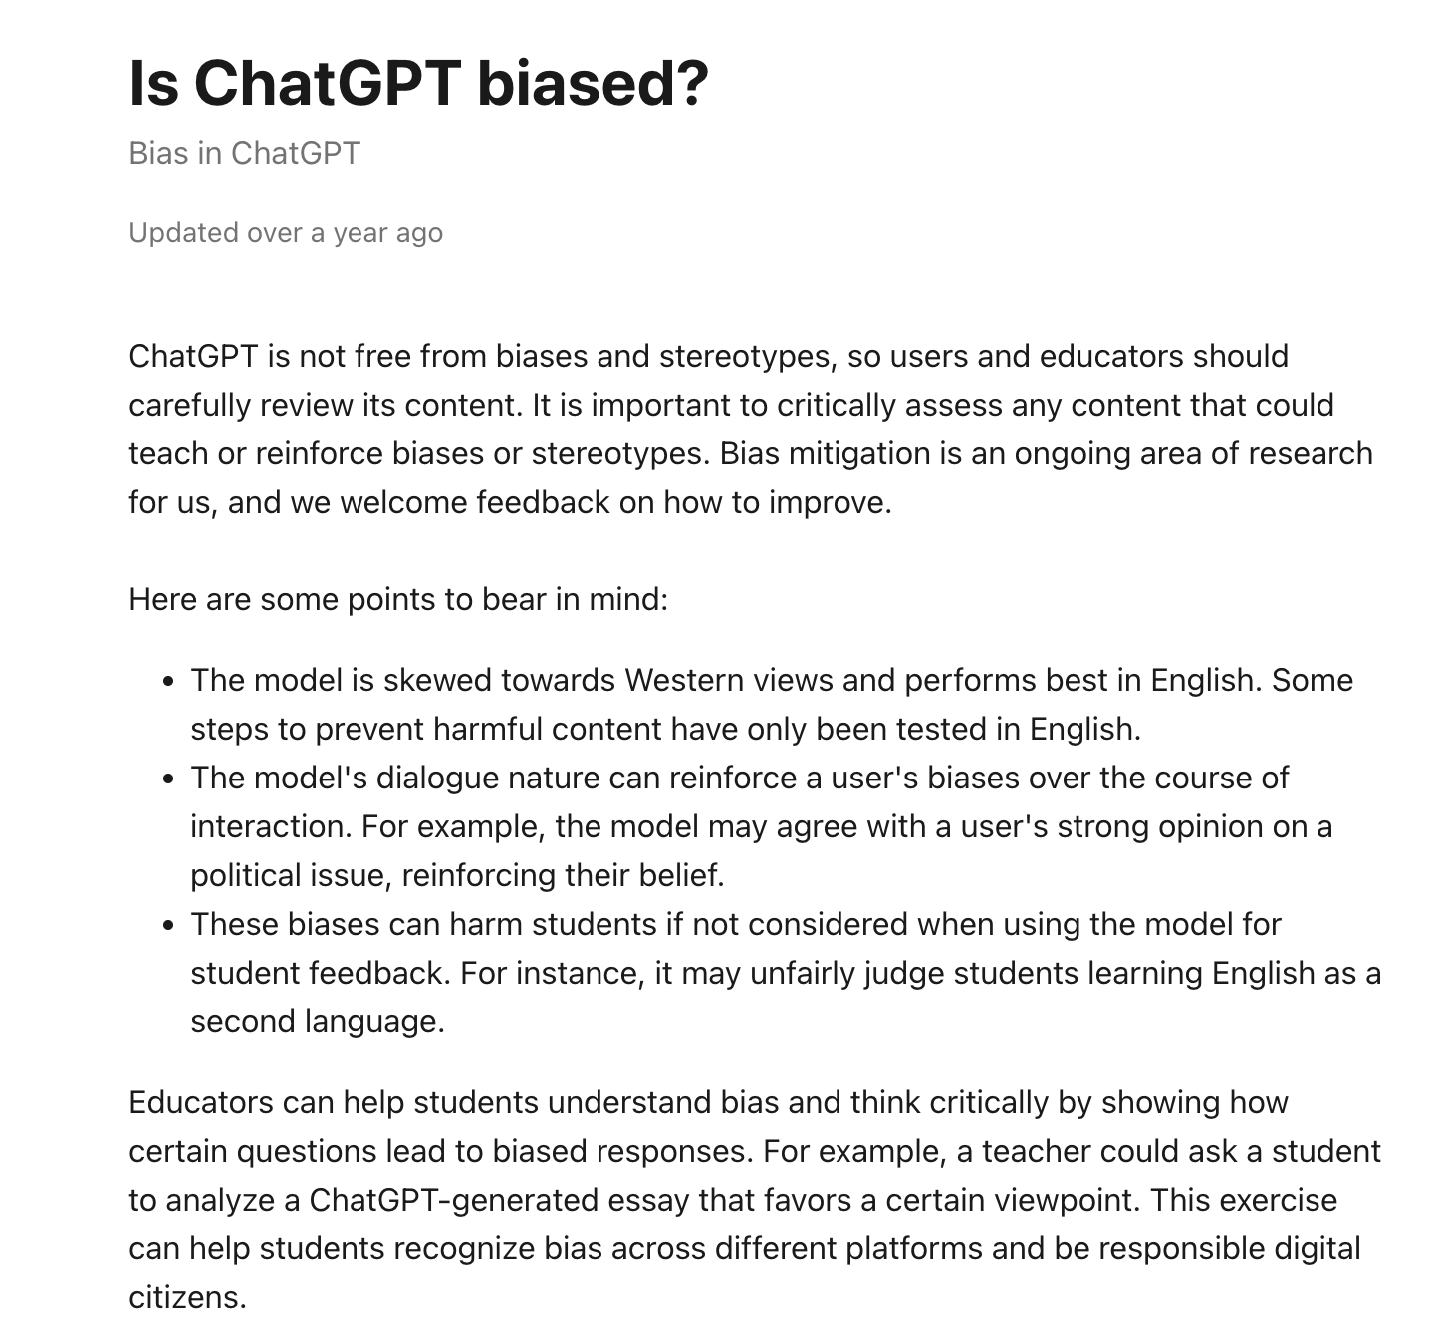

* How do we teach with AI without losing student trust?
  + Our thoughts: The teacher could abuse AI and be using it to grade; degrading the relationship between the student and teacher. Could ask ChatGPT to generate suggestions about how to grade, not simply grade the work of the students.
  + Our thoughts: Because the Student is using AI they could be limiting their ability to learn by limiting their usage.
  + Possible solution: Frame AI as a tool. Encourage students to check integrity and think critically.
  + Possible solution: Direct communicate the roles of AI in teaching
  + Possible solution: Show examples when AI can give inaccurate and biased information
  + Consideration: The teacher needs to already have established trust/respect with a teacher before they can lose it from LLM.
  + Consideration: How can a user ensure that the LLM tool they select is appropriate to gain the trust of the students?

**Ethical Principles Commitment**

*A sentence or two on the ethical principles you are prioritizing, for example, privacy, language, accessibility.*

Our Chatbot, ClassAI, prioritizes the ethical considerations of data privacy and cultural sensitivity by following these frameworks:

* + - * Data privacy: Our Chatbot protects sensitive student and school information by providing educators with a disclaimer at the start of a chat which informs the user that they should refrain from sharing any personal or sensitive details about their students, their schools, or their communities. The Chatbot shares in the disclaimer what it will do with the information, how it may be used to train other LLMs, and how long it might keep the information stored. The Chatbot will provide a link to instructions for how to delete data and/or previous chat conversations should a user share information that they do not wish the Chatbot to retain.
      * Cultural sensitivity: Our Chatbot has been provided literature to inform its processing that highlight the needs of diverse students and educators within the classroom so that it generates responses that consider the different ages, backgrounds, and languages of students, their caregivers, and the educators in the community.

|  |  |
| --- | --- |
| **Brainstorming about Ethical Considerations** | |
| **Ethical Dimension** | **Questions we to consider for how we might prioritize these ethical principles** |
| Language Accessibility | Q: How do we effectively communicate with students based their age and background?  A: Ask Chatbot to think of reading level when providing example tools to use and explain the limitations to different resources suggested in reference to the cultural backgrounds the models have been trained on. |
| Data Privacy | Q: How do we protect the sensitive student and/or school data that educators might share when asking a prompt in our Chatbot?  A: Provide a disclaimer on what the Chatbot does with the data (the information) that the educator might share when asking it prompts.  Future research: Turning off the memory of the Chatbot and could the Chatbot only be accessed on the school network and when the educator is logged in to their credentials? |
| Empathy and Tone | Q: How do we make sure that educators who are wary of AI do not feel scared or put off from using AI?  A: Reducing the complexity of responses from the Chatbot, removing jargon, providing resource guides, tone is friendly |
| Cultural Sensitivity | Q: What would the AI Chatbot recommend for tools/resources that can be applied in elementary vs high school or college settings? Rural vs urban? Students that have English as a Second Language (ESL)? Students who are in special education classes? Students who are undocumented or have immigrated to the area?  A: Ask the Chatbot to come up with culturally specific examples that outline in what contexts these resources or tools would be applicable and explain its reasoning. |

**Data Privacy and Consent Policy**

*How are you addressing the data that the chatbot is training on, what disclaimers might you include with the chatbot, how are you addressing user consent?*

Because we have no control over the information that ChatGPT will obtain we need to portray the risks associated with providing ChatGPT with personally identifiable information. At the launch of each chat session, users will receive a brief but clear message summarizing their rights, with an option to read the full Data Privacy and Ethics Policy.

As residents of California, you may have specific rights under data protection laws in relation to your Personal Data. You may have the right to:

* The right to know about the personal information a business collects about them and how it is used and shared
* The right to delete personal information collected from them (with some exceptions)
* The right to opt-out of the sale or sharing of their personal information including via the GPC
* The right to non-discrimination for exercising their CCPA rights.

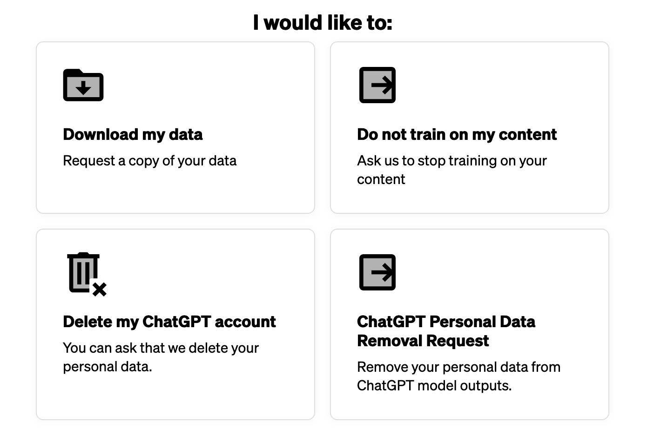

**User Rights and Protections**

*If an ethical principle is violated, what rights does the user have and who is their point of contact or nodal agency to address this? How will this be clear and communicated to the user?*

Our chatbot, ClassAI, is committed to protecting the rights and autonomy of its users, primarily educators seeking guidance on ethical AI use in classrooms.  
User rights and protections are communicated clearly at the start of each chat session through an introductory disclaimer. These rights include:

* **Right to Informed Use**:  
  Users are informed that the chatbot does not store personal or sensitive data unless explicitly stated, and that any shared information should not include identifiable student or school details.
* **Right to Privacy and Consent**:  
  Users have the right to opt out of any data collection. They are provided with links to instructions for requesting data deletion if personal data is accidentally shared.
* **Right to Fairness and Bias Review**:  
  If users encounter outputs they believe are biased, inaccurate, or ethically questionable, they may report the interaction. A human review process will evaluate these cases to ensure accountability and continuous improvement.
* **Right to Non-Discrimination**:  
  Users will not experience different levels of service based on their background, role, or any personal characteristic. Educators from diverse communities, including special education, ESL contexts, and underrepresented backgrounds, will be treated equitably.
* **Right to Point of Contact**:  
  Concerns, complaints, or data privacy requests can be submitted to the designated Ethics and Compliance Contact at info@classai.com. The chatbot will include a visible and accessible link to this contact information within its interface.

**Closing Affirmation**

*Write a short paragraph reiterating the key principles and commitments to ethical use of your chatbot.*

ClassAI is an AI-chatbot technology that empowers educators. It does not replace their professional judgment, intuition, and care.  
Our chatbot is guided by the ethical principles of privacy, equity, critical thinking, and cultural sensitivity.

We are committed to:

* Supporting thoughtful, reflective decision-making about AI use in classrooms.
* Helping educators recognize and navigate bias, inequity, and transparency issues.
* Protecting the privacy and dignity of all students and communities.
* Promoting AI literacy that enhances — rather than diminishes — the human elements of teaching and learning.

ClassAI stands as a trusted ethical partner, helping educators lead the next generation into a future where AI serves humanity with fairness, respect, and care.